1)

vk<-arima.sim(n=1500,list(order(2,0,1),ar=c(0,0.25),ma=0.4))

#1

acvf_vk<-acf(vk,type="covariance")

fft_acvf<-(fft(acvf_vk$acf)+ fft(acvf_vk$acf,inverse= TRUE))/2

#2

vk1=arma.spec(ar=c(0,0.25),ma=0.4)

plot(vk1)

plot(acvf_vk$lag[1:15]/30,fft_acvf[1:15],'l',xlab='frequency',ylab='spectrum')

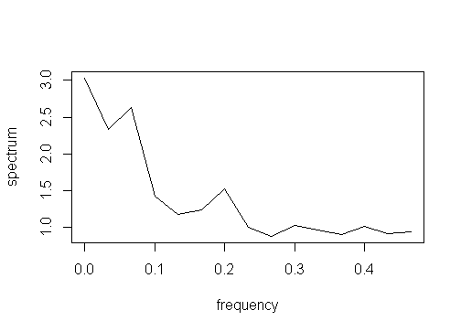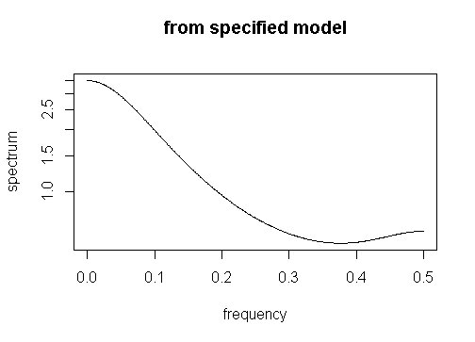

4)

ave=1:1000

for (i in 1:1000)

{

xk<-arima.sim(n=1000,list(order(0,0,1),ma=0.4))

acvf_xk<-acf(xk,type="covariance")

sum=0

for (l in 2:31)

{

sum=sum+(1-l/1000)*acvf_xk$acf[l]

}

sum=sum*2

var_xbar=(acvf_xk$acf[1]+sum)/1000

ave[i]=var_xbar

}

var_xbar_monte=mean(ave)

3)

nottem=nottem

plot(nottem)

acf(nottem) #Periodic for every lag (MA(1)

pacf(nottem)#AR(5)

psd=spectrum(nottem)

t=1:240

tr_fit<-lm(nottem~t)

plot(tr_fit$residuals,type='l')

acf(tr_fit$residuals)

pacf(tr_fit$residuals)

plot(psd)

arma_a<-arma(tr_fit$residuals,order=(c(5,1)))

plot(arma_a)

